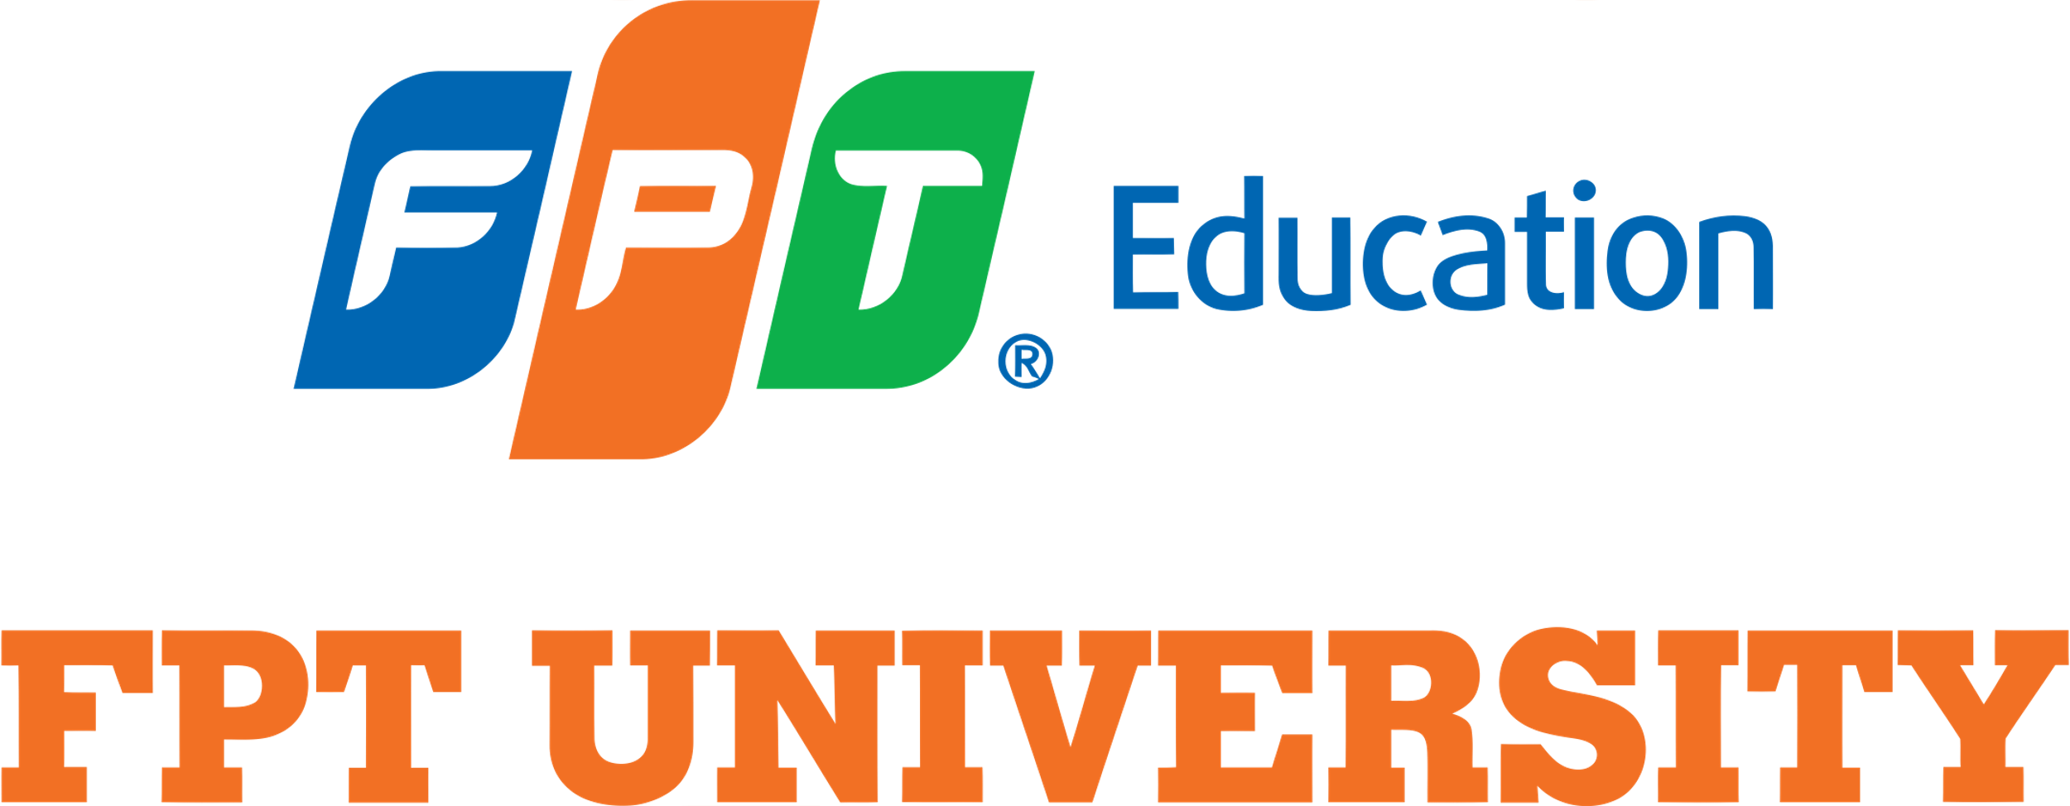

CASE STUDY 1 WEEK 3

There are 5 different types of unfair advantages (insights) that your company have and companies do not have all of them. It’s nice if you have two or three but for most of you it’s probably just one (Kevin Hale, 2019).

- Founder: Are you one in ten of all the people in the world who can solve this problem? Do you have a special expertise or experience that sets you apart from others?
- Market: Is your market growing 20% a year? If you're in a growing market, you'll automatically grow with it.
- Product: Is your product 10x better than the competition? If your product is significantly better, you'll have an unfair advantage.
- Acquisition: Do you have a way to acquire customers for free or at a very low cost? If you can grow through word-of-mouth or other low-cost acquisition channels, you'll have an unfair advantage.
- Monopoly: As your company grows, does it become more difficult for competitors to defeat you? Do you have a network effect or a winner-takes-all market that makes it hard for others to catch up?

Case Study: Y Combinator (Kevin Hale, 2019).
- Problem: Hard for founders to raise money without knowing someone in venture capital.
- Solution: YC invests in companies through an open application (let investors know about the idea, about founder)
- Insight:
a. Founder: Paul Graham had wrote a textbook on LISP, a programmer, had built and sold the first SAS company.
b. Market: Future billion companies would be technology or software startups. Software startups need less money.
c. Product: covering 3-month living expenses is enough. Hacker want to do this. No coworking space is better. Other angels/ VCs want to invest in these startups.
d. Acquisition: PG wrote books and online essays with a large audience of target users: hackers.
e. Monopoly: YC Alumni network more valuable than partners. Easier to recruit. Scales advice. Better beta.
- Results: YC is a community of over 4000 founders, include CEOs of $1B+ companies (Airbnb, dropbox, reddit…), total market capitalization is over $100 billion (Kevin Hale, 2019).

Source: Kevin Hale - How to evaluate startup ideas (2019) YouTube. Available at: YouTube (Accessed: 07 June 2024).

